Universitatea Tehnică a Moldovei

Facultatea Calculatoare, Informatică și Microelectronică

Departamentul Ingineria Software și Automatică

Raport

la Lucrarea de laborator nr. 2

la disciplina Tehnologii Web

Tema: Proiectarea unei pagini Web utilizând ASP.NET

Studentul gr. TI-173: Heghea Nicolae

Conducător: asistent universitar, Rusu Cristian

Cuprins

1. Scopul : 3

2. Sarcina lucării 3

3. Scurtă teorie 3

4. Realizare 4

5. Rezultat 15

# Scopul :

În Visual Studio de creat un proiect pe platforma ASP .Net și de adăugat în el conținutul paginii web.

# Sarcina lucării

Implementarea cunoștințelor acumulate în crearea unei pagini web, și a unui proiect în ASP .Net.

# Scurtă teorie

Structura unei aplicatii ASP.NET MVC

|  |  |
| --- | --- |
| Directoriul | Folderul proiectului |
| /Controllers | Contine clasele pentru Controller ce gestioneaza cererile URL |
| /Models | Contine clasele ce reprezinta datele modelului,  Gestionarea acestor obiecte. |
| /Views | Contine fisiere template UI responsabile pentru afisarea rezultatului. |
| /Scripts | Contine biblioteci JavaScript si scripturi (.js). |
| /App_Data | Contine fisierele de date Read/Write. DB. |
| /App_Start | Contine cod de configurare, grupari de fisiere si Web API. |
| /Content | Contine fisierele CSS |
| /Images | Contine imaginile folosite in cadrul aplicatiei. |

Aceasta structura este generata (nu in totalitate) de catre VS. Se poate folosi si o structura personalizata in sensul adaugarii a altor noi foldere.

# Realizare

Site-ul pe care l-am făcut este un site de tip porfoliu. În el am inclus căteva pagini, și anume : *home, profile, login, sign up, about* și *contact*.

Conținutul proiectului :

|  |  |
| --- | --- |
|  |  |

Conținutul fișierului *BundleConfig.cs*

|  |
| --- |
| using System.Web;  using System.Web.Optimization;  namespace TW.Hejea.Web  {  public class BundleConfig  {  public static void RegisterBundles(BundleCollection bundles)  {  bundles.Add(new ScriptBundle("~/bundles/jquery/js").Include(  "~/Scripts/jquery-{version}.js"));  bundles.Add(new ScriptBundle("~/bundles/jqueryval/js").Include(  "~/Scripts/jquery.validate*"));  bundles.Add(new ScriptBundle("~/bundles/bootstrap/js").Include(  "~/Scripts/bootstrap.js"));  bundles.Add(new StyleBundle("~/bundles/bootstrap/css").Include(  "~/Content/bootstrap.css",  "~/Content/site.css"));  bundles.Add(new StyleBundle("~/bundles/argon/css").Include(  "~/Vendors/css/argon.css", new CssRewriteUrlTransform()));  bundles.Add(new ScriptBundle("~/bundles/argon/js").Include(  "~/Vendots/js/argon.js"));  bundles.Add(new ScriptBundle("~/bundles/headroom/js").Include(  "~/Vendots/js/headroom.min.js"));  bundles.Add(new ScriptBundle("~/bundles/popper/js").Include(  "~/Scripts/popper.js"));  }  }  } |

Conținutul fișierului *RouteConfig.cs*

|  |
| --- |
| using System;  using System.Collections.Generic;  using System.Linq;  using System.Web;  using System.Web.Mvc;  using System.Web.Routing;  namespace TW.Hejea.Web  {  public class RouteConfig  {  public static void RegisterRoutes(RouteCollection routes)  {  routes.IgnoreRoute("{resource}.axd/{*pathInfo}");  routes.MapRoute(  name: "Default",  url: "{controller}/{action}/{id}",  defaults: new { controller = "Home", action = "Index", id = UrlParameter.Optional }  );  }  }  } |

Conținutul fișierului *HomeController.cs*

|  |
| --- |
| using System;  using System.Collections.Generic;  using System.Linq;  using System.Web;  using System.Web.Mvc;  namespace TW.Hejea.Web.Controllers  {  public class HomeController : Controller  {  public ActionResult Index()  {  ViewBag.Title = "Home";  return View();  }  public ActionResult About()  {  return View();  }  public ActionResult Contact()  {  return View();  }  public ActionResult Login()  {  return View();  }  public ActionResult Info()  {  return View();  }  public ActionResult Register()  {  return View();  }  }  } |

Conținutul fișierului *_ViewStart.cshtml*

|  |
| --- |
| @{  Layout = "~/Views/Shared/_Layout.cshtml";  } |

Conținutul fișierului *_Layout.cshtml*

|  |
| --- |
| <!DOCTYPE html>  <html>  <head>  <meta http-equiv="Content-Type" content="text/html; charset=utf-8" />  <meta name="viewport" content="width=device-width, initial-scale=1.0">  <meta http-equiv="X-UA-Compatible" content="IE=edge">  <title>TW | @ViewBag.Title</title>  <link rel="icon" href="~/Vendors/img/tw.png" type="image/png">  <link href="https://fonts.googleapis.com/css?family=Open+Sans:300,400,600,700" rel="stylesheet">  <!-- Add local styles, mostly for plugins css file -->  @if (IsSectionDefined("Styles"))  {@RenderSection("Styles", required: false)}  <!-- Primary HOME style -->    @Styles.Render("~/bundles/argon/css")  </head>  <body>  <div class="wrapper">  <!-- Header -->  <header class="header-global">  <nav id="navbar-main" class="navbar navbar-main navbar-expand-lg navbar-transparent navbar-light headroom headroom--not-bottom headroom--pinned headroom--not-top">  @Html.Partial("_Header")  </nav>  </header>  <!-- Main view -->  <section class="content">  @RenderBody()  <!-- Footer-->  @Html.Partial("_Footer")  </section>  <!-- Section for main scripts render -->  @Scripts.Render("~/bundles/jquery/js")  @Scripts.Render("~/bundles/popper/js")  @Scripts.Render("~/bundles/headroom/js")  @Scripts.Render("~/bundles/argon/js")  <!-- Handler for local scripts -->  @RenderSection("scripts", required: false)  </div>  </body>  </html> |

Conținutul fișierului *_Header.cshtml*

|  |
| --- |
| <div class="container">  <div class="container navbar-collapse collapse" id="navbar_global">  <ul class="navbar-nav navbar-nav-hover align-items-lg-center ">  <li class="nav-item">  <a class="nav-link" href="@Url.Action("Index","Home")">  Home  </a>  </li>  <li class="nav-item">  <a class="nav-link" href="@Url.Action("Info","Home")">  Profile  </a>  </li>  <li class="nav-item">  <a class="nav-link" href="@Url.Action("Login","Home")">  Login  </a>  </li>  <li class="nav-item">  <a class="nav-link" href="@Url.Action("Register","Home")">  Sign up  </a>  </li>  <li class="nav-item">  <a class="nav-link" href="@Url.Action("About","Home")">  About  </a>  </li>  <li class="nav-item">  <a class="nav-link" href="@Url.Action("Contact","Home")">  Contact  </a>  </li>  </ul>  <ul class="navbar-nav align-items-lg-center ml-lg-auto">  <li class="nav-item glyphicon-align-right">  <a href="@Url.Action("Info","Home")" class="nav-link ">  <span class="mr-3">Hejea Nicolae</span>  <img src="~/Vendors/img/me.png" alt="Raised image" class="img-fluid rounded card-profile-image" style="width: 50px;">  </a>  </li>  </ul>  </div>  </div> |

Conținutul fișierului *_Footer.cshtml*

|  |
| --- |
| <footer class="footer">  <div class="container">  <div class="row align-items-center justify-content-md-between">  <div class="col-md-6">  <div class="copyright">  &copy; 2019  <a href="https://www.creative-tim.com" target="_blank">UTM</a>.  </div>  </div>    </div>  </div>  </footer> |

Conținutul fișierului *Index.cshtml*

|  |
| --- |
| <main>  <div class="position-relative">  <section class="section section-lg section-shaped pb-300">  <div class="shape shape-style-1 shape-default">  </div>  <div class="container py-lg-md d-flex">  <div class="col px-0">  <div class="row">  <div class="col-lg-6">    <h1 class="display-3 text-white">  Un sistem de design frumos  <span>completat cu exemple</span>  </h1>    </div>  </div>  </div>  </div>  </section>  </div>  </main> |

Conținutul fișierului *About.cshtml*

|  |
| --- |
| @{  ViewBag.Title = "About";  }  <main>  <section class="position-relative">  <div class="container">  <section class="section section-lg section-shaped pb-100">  <div class="card shadow mt-5">  <div class="shape shape-style-1 shape-default">  </div>  <div class="text-center mt-5 mb-5">  <section class="section section-lg section-shaped">  <h2>@ViewBag.Title.</h2>  <h3>About page</h3>  </section>  </div>  </div>  </section>  </div>  </section>  </main> |

Conținutul fișierului *Contact.cshtml*

|  |
| --- |
| @{  ViewBag.Title = "Contact";  }  <main>  <section class="section">  <div class="container">  <div class="row justify-content-center py-lg-5 mt-xl-5">  <div class="col-lg-8">  <div class="card bg-gradient-secondary shadow">  <div class="card-body p-lg-5">  <h4 class="mb-1">Want to work with us?</h4>  <p class="mt-0">Your project is very important to us.</p>  <div class="form-group mt-5">  <div class="input-group input-group-alternative">  <div class="input-group-prepend">  <span class="input-group-text"><i class="ni ni-user-run"></i></span>  </div>  <input class="form-control" placeholder="Your name" type="text">  </div>  </div>  <div class="form-group">  <div class="input-group input-group-alternative">  <div class="input-group-prepend">  <span class="input-group-text"><i class="ni ni-email-83"></i></span>  </div>  <input class="form-control" placeholder="Email address" type="email">  </div>  </div>  <div class="form-group mb-4">  <textarea class="form-control form-control-alternative" name="name" rows="4" cols="80" placeholder="Type a message..."></textarea>  </div>  <div>  <button type="button" class="btn btn-default btn-round btn-block btn-lg">Send Message</button>  </div>  </div>  </div>  </div>  </div>  </div>  </section>  </main> |

Conținutul fișierului *Info.cshtml*

|  |
| --- |
| @{  ViewBag.Title = "Profile";  }  <main>  <section class="position-relative">  <div class="container">  <section class="section section-lg section-shaped pb-200">  <div class="card card-profile shadow mt-5">  <div class="text-center mt-5 mb-5">  <h3>  Hejea Nicolae  </h3>  <div class="h6 font-weight-300"><i class="ni location_pin mr-2"></i>Chisinau, Moldova</div>  <div><i class="ni education_hat mr-2"></i>Universitatea Tehnica A Moldovei</div>  </div>  </div>  </section>  </div>  </section>  </main> |

Conținutul fișierului *Login.cshtml*

|  |
| --- |
| @{  ViewBag.Title = "Contact";  }  <main>  <section class="section section-shaped section-lg">    <div class="shape shape-style-1 bg-gradient-default">  <span></span><span></span><span></span><span></span><span></span><span></span><span></span><span></span>  </div>  <div class="container pt-lg-md">  <div class="row justify-content-center">  <div class="col-lg-5">  <div class="card bg-secondary shadow border-0">  <div class="card-header bg-white pb-5">    <div class="text-muted text-center mb-3">  <small>Sign in with</small>  </div>  <div class="btn-wrapper text-center">  <a href="#" class="btn btn-neutral btn-icon">  <span class="btn-inner--icon">    </span>  <span class="btn-inner--text">Github</span>  </a>  <a href="#" class="btn btn-neutral btn-icon">  <span class="btn-inner--icon">    </span>  <span class="btn-inner--text">Google</span>  </a>  </div>  </div>  <div class="card-body px-lg-4 py-lg-4">  <div class="text-center text-muted mb-4">  <small>Or sign in with credentials</small>  </div>  <form role="form">  <div class="form-group mb-4">  <div class="input-group input-group-alternative">  <div class="input-group-prepend">  <span class="input-group-text"><i class="ni ni-email-83"></i></span>  </div>  <input class="form-control" placeholder="Email" type="email">  </div>  </div>  <div class="form-group">  <div class="input-group input-group-alternative">  <div class="input-group-prepend">  <span class="input-group-text"><i class="ni ni-lock-circle-open"></i></span>  </div>  <input class="form-control" placeholder="Password" type="password">  </div>  </div>  <div class="custom-control custom-control-alternative custom-checkbox">  <input class="custom-control-input" id=" customCheckLogin" type="checkbox">  <label class="custom-control-label" for=" customCheckLogin">  <span>Remember me</span>  </label>  </div>  <div class="text-center">  <button type="button" class="btn btn-primary my-4">Sign in</button>  </div>  </form>  </div>  </div>  <div class="row mt-3">  <div class="col-6">  <a href="#" class="text-light">  <small>Forgot password?</small>  </a>  </div>  <div class="col-6 text-right">  <a href="#" class="text-light">  <small>Create new account</small>  </a>  </div>  </div>  </div>  </div>  </div>  </section>  </main> |

Conținutul fișierului *Register.cshtml*

|  |
| --- |
| @{  ViewBag.Title = "Sign up";  }  <main>  <section class="section section-shaped section-lg">  <div class="shape shape-style-1 bg-gradient-default">  </div>  <div class="container pt-lg-md">  <div class="row justify-content-center">  <div class="col-lg-5">  <div class="card bg-secondary shadow border-0">  <div class="card-header bg-white pb-5">  <div class="text-muted text-center mb-3">  <small>Sign up with</small>  </div>  <div class="text-center">  <a href="#" class="btn btn-neutral btn-icon mr-4">  <span class="btn-inner--text">Github</span>  </a>  <a href="#" class="btn btn-neutral btn-icon">  <span class="btn-inner--text">Google</span>  </a>  </div>  </div>  <div class="card-body px-lg-4 py-lg-4">  <div class="text-center text-muted mb-4">  <small>Or sign up with credentials</small>  </div>  <form role="form">  <div class="form-group">  <div class="input-group input-group-alternative mb-3">  <div class="input-group-prepend">  <span class="input-group-text"><i class="ni ni-hat-3"></i></span>  </div>  <input class="form-control" placeholder="Name" type="text">  </div>  </div>  <div class="form-group">  <div class="input-group input-group-alternative mb-3">  <div class="input-group-prepend">  <span class="input-group-text"><i class="ni ni-email-83"></i></span>  </div>  <input class="form-control" placeholder="Email" type="email">  </div>  </div>  <div class="form-group">  <div class="input-group input-group-alternative">  <div class="input-group-prepend">  <span class="input-group-text"><i class="ni ni-lock-circle-open"></i></span>  </div>  <input class="form-control" placeholder="Password" type="password">  </div>  </div>    <div class="row my-4">  <div class="col-12">  <div class="custom-control custom-control-alternative custom-checkbox">  <input class="custom-control-input" id="customCheckRegister" type="checkbox">  <label class="custom-control-label" for="customCheckRegister">  <span>I agree with the  <a href="#">Privacy Policy</a>  </span>  </label>  </div>  </div>  </div>  <div class="text-center">  <button type="button" class="btn btn-primary mt-4">Create account</button>  </div>  </form>  </div>  </div>  </div>  </div>  </div>  </section>  </main> |

Conținutul fișierului *Global.asax*

|  |
| --- |
| using System;  using System.Collections.Generic;  using System.Linq;  using System.Web;  using System.Web.Mvc;  using System.Web.Optimization;  using System.Web.Routing;  using System.Web.Security;  using System.Web.SessionState;  namespace TW.Hejea.Web  {  public class MvcApplication : System.Web.HttpApplication  {  protected void Application_Start()  {  AreaRegistration.RegisterAllAreas();  FilterConfig.RegisterGlobalFilters(GlobalFilters.Filters);  RouteConfig.RegisterRoutes(RouteTable.Routes);  BundleConfig.RegisterBundles(BundleTable.Bundles);  }  }  } |

# Rezultat

Pagina *home* :

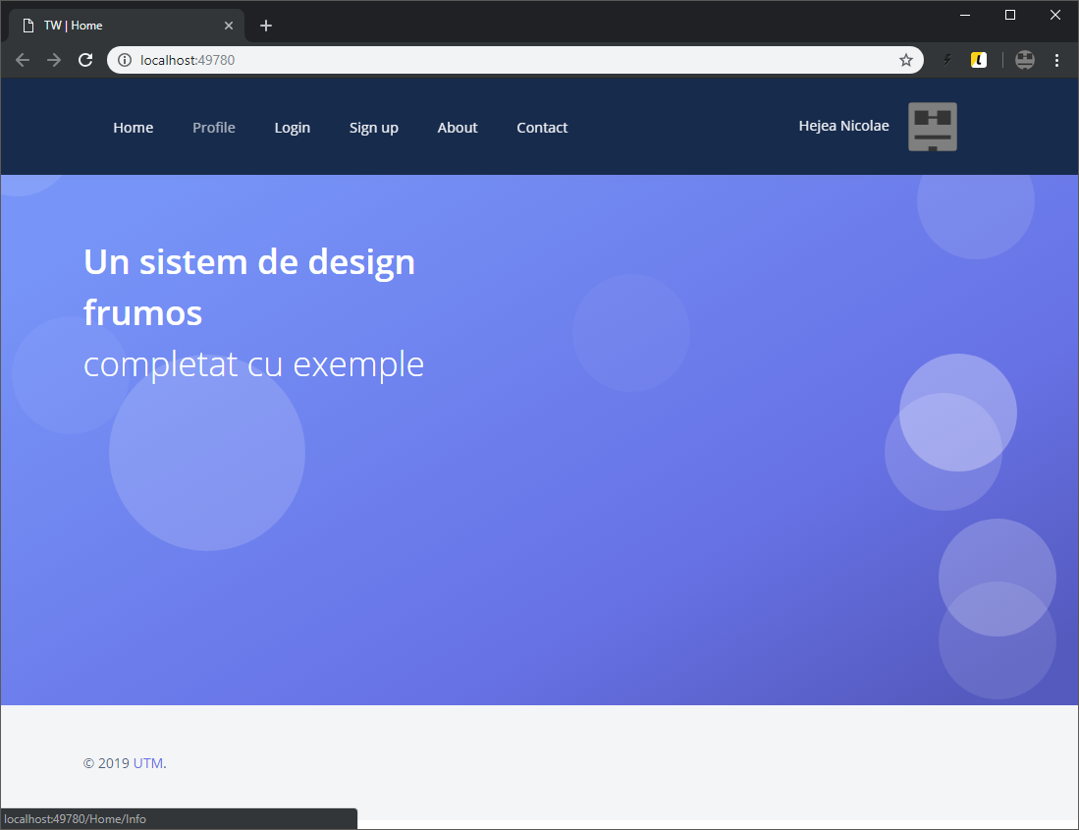

Pagina *profile* :

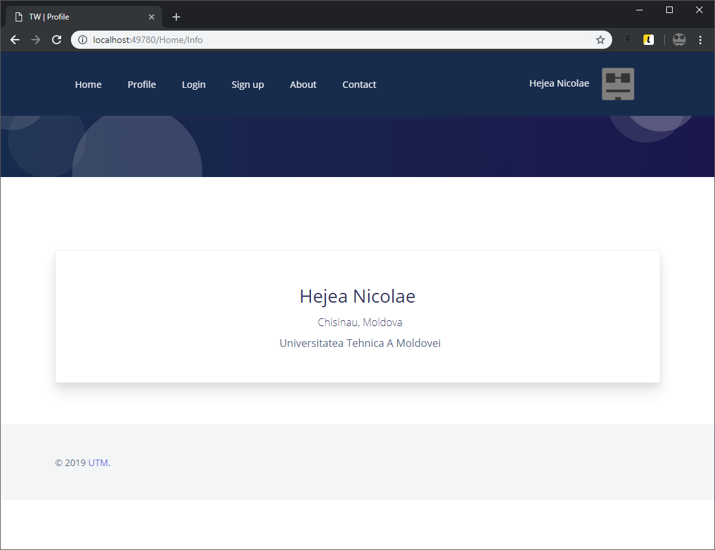

Pagina login :

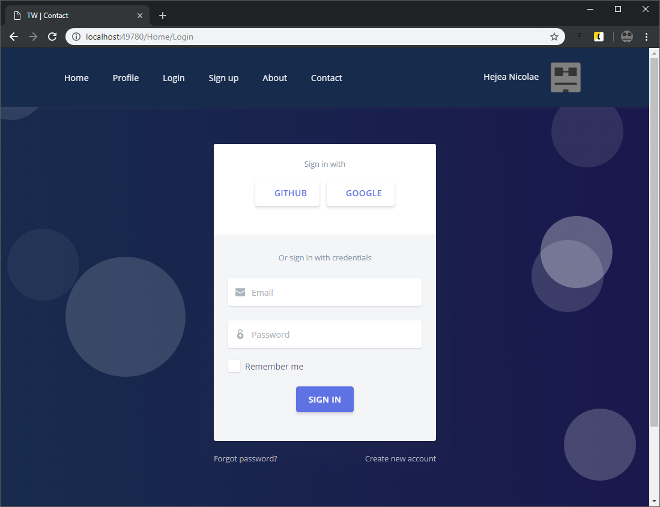

Pagina sign up :

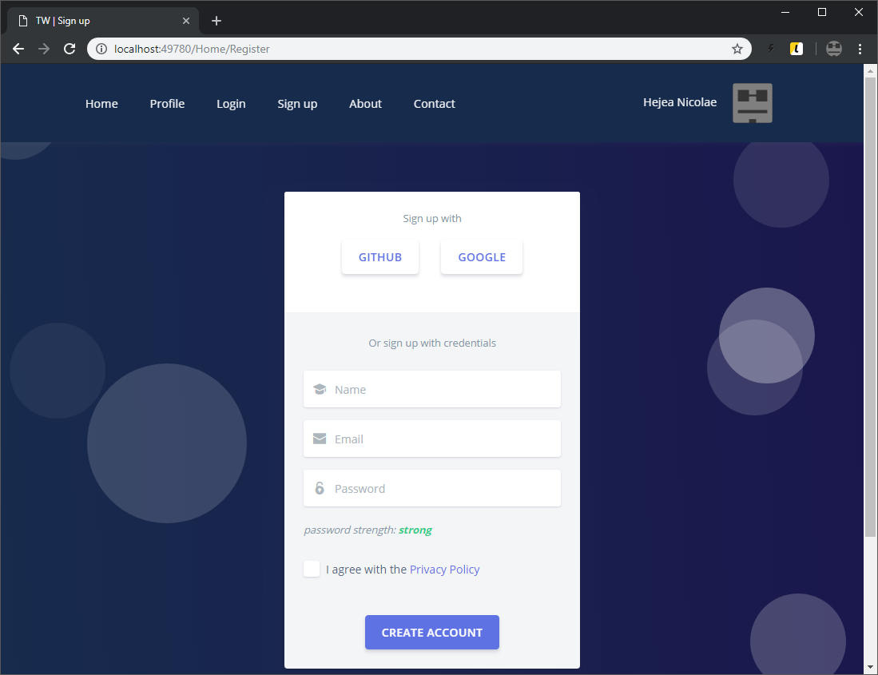

Pagina about :

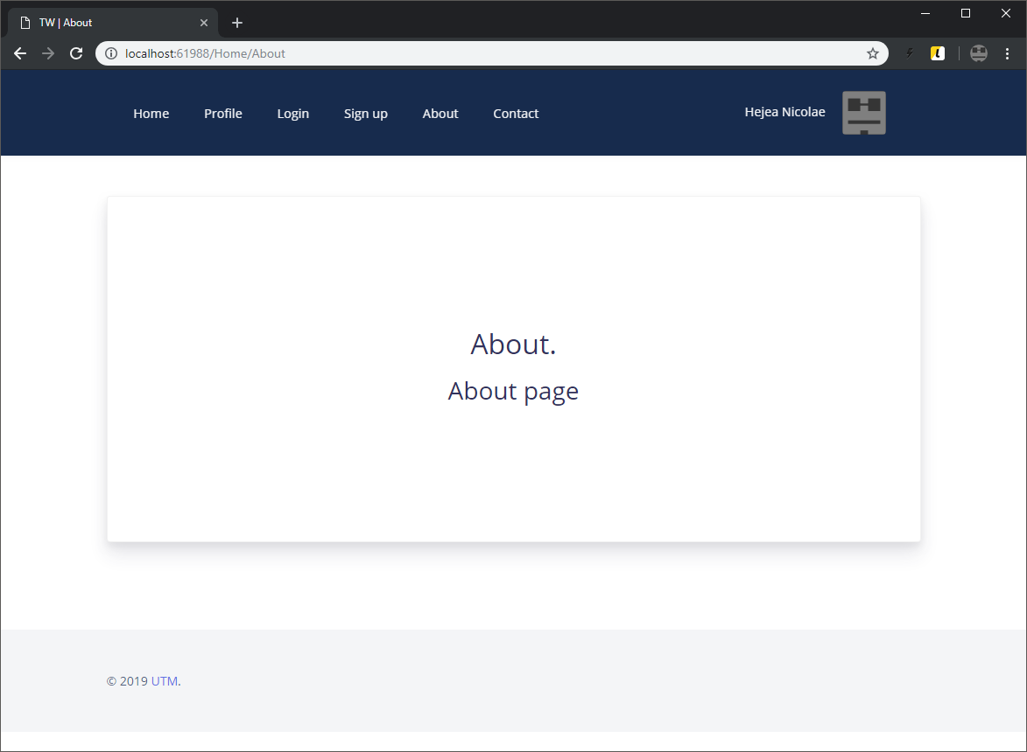

Pagina contact :

